Sikh migration project launch: How will you tell your story?
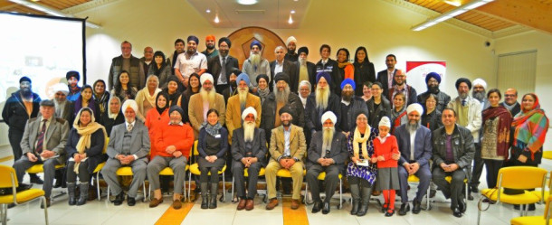
Guests at the launch of ‘My Story-Our Journey’ at the Nishkam Centre

“We are all refugees and migrants on this planet”, said Bhai Sahib Bhai Mohinder Singh (OBE KSG, Chairman of Nishkam Civic Association), during the launch of the Sikh Migration research project at the Nishkam Centre on 25th January 2017 to an audience keen to participate in the project. “Where did I come from? “Where are your roots? What is my destination?”

The questions posed describe the essence of the project ‘My Story- Our Journey’, launched by the Nishkam Civic Association. The Sikh migration project, secured a grant from the Heritage Lottery Fund (HLF), aims to capture the retrospective journey of the Sikh population in Birmingham and the Black Country, from the first generation to the current day, through collecting oral histories from those who have experienced and grown up with the migrant journey.
The launch was attended by the project’s steering committee members, which included Councillor Preet K Gill (Sandwell) Suwinder Bains, Partnership and Community Engagement Manager (Birmingham City Council), Jasbir Singh Uppal (University of Wolverhampton), Manjeet

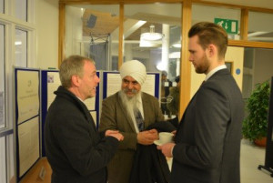
Guests arriving, networking and sharing stories
Kaur (Media and Heritage Volunteer) and Surinder Singh, Electoral officer (Sandwell) who said “As a person who has a strong connection with working in both Birmingham and the Black Country it was wonderful to see so many people showing a passionate interest and also a willingness to work together on this unique project. With this passion and energy I am sure ‘My Story – Our Journey’ will create a lasting legacy for the contribution of the Sikh Community in our region and we look forward to seeing and hearing some wonderful and amazing stories”

The diverse audience also included author Jatinder Kaur, who is currently promoting her recent biography of her father, Bhai Sahib Rajinder Singh Ji, titled ‘Chalda Vaheer Jatha: A Spiritual Journey’.

Jatinder briefly spoke about her father’s journey to the UK, settling in Dudley, and the motives behind the transition. She wrote the biography with the help of her father’s diary, which was his ‘voice and guidance’ in writing the book. In her journey in capturing his story, she conducted face-to-face interviews with each person he had met on his international travels in promoting Sikh values, and discovered first-hand the feelings behind the stories of persecution and challenged identity.

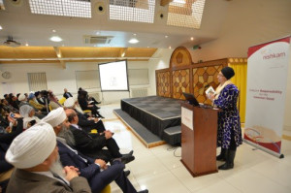
Jatinder Kaur: Author of ‘Chalda Vaheer Jatha: A Spiritual Journey’.

Rachel Chui (HLF, Committee Member for the West Midlands) was also among the speakers. After hearing the detailed account of the aims and timescales of the project, she spoke about her thoughts on the research: “Heritage is about the intangible – you can’t touch stories. People from all walks of life can contribute to the various histories and shared experiences.” Rachel poignantly added that we have “more in common than our differences.”

Ajit Singh, Contracts Manager (Nishkam Centre) and Inderdeep Kaur Shambi, Project Lead, gave a detailed account of how the project started, and the proposed deliverables.

The project aims to record and collate 30 oral histories, ranging from first generation migrants to the present, and whilst doing so, recruit and train a large number of volunteers with a variety of skills. Photographs will also be collected, which will be used in the touring exhibitions at a number of high profile locations, including the Birmingham Museum and Art Gallery, University of Wolverhampton among many others.
A website will also be developed, to include all the collated research in an accessible and user-friendly format. The project will leave a visible legacy after its completion, in the form of a publication and all contributions will be archived at the Library of Birmingham and Sandwell Archives and an education toolkit will be developed for local schools, encouraging young students to learn about oral history, stories and migration in fun and engaging ways.

The launch received positive feedback from those who attended, Ravinderjit Kaur Briah, a lecturer at De Montfort University, said the project

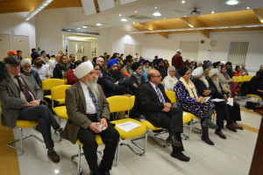
Listening attentively on how ‘My Story – Our Journey’ will be encapsulated

was an “inspiration”, and this had been a “long time coming and well overdue”. She added that the project would “provide a springboard for so many other projects, and will leave a lasting legacy.”
The ‘My Story-Our Journey’ project has already received coverage from BBC Midlands Today and is capturing the attention of not only the Sikh community, but also all those intrigued by remembering and sharing stories which would otherwise be left untold and uncaptured. Satnam Rana (Midlands Today) discussed with the team possible future input and her own very personal stories.

In order to create a full tapestry of Sikh migration in Birmingham and The Black Country the project is looking to interview and collaborate with a diverse range of Sikh voices as well as collate personal photographs that depict moments in time.

The project is also keen to capture experiences of non-Sikh people who have had experiences or opportunities of working or living with Sikhs.

